While creating an instances through the command line we can develope the equivalent command line from the GCP console. While developing we have to enter the start up script to udate the system. The script is as follows in the bin bash :

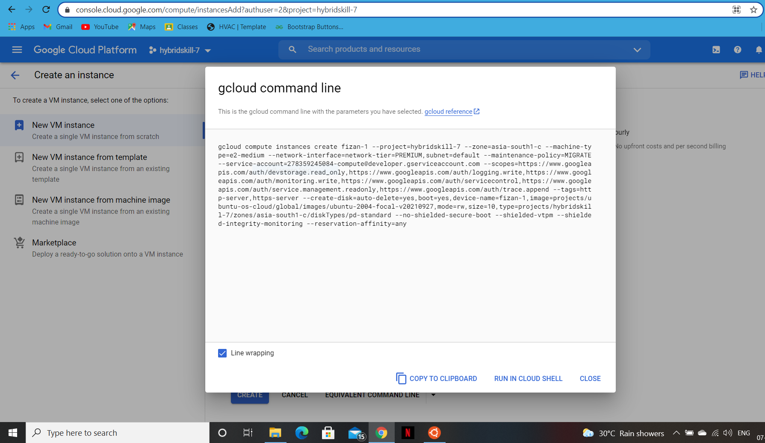

#! /bin/bash apt update apt -y install apache2 cat < /var/www/html/index.html

Linux startup script added directly.

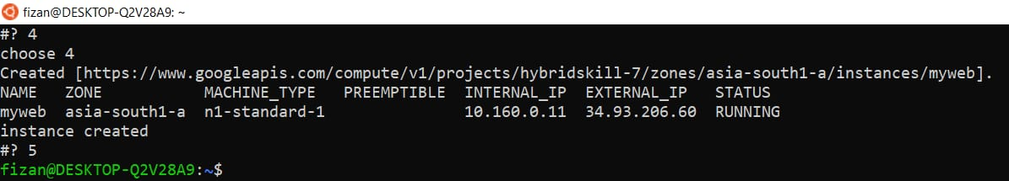

This will update the system instance while creating the instance through command line. Then while creating the instance we can add on more scripts to make them vm more flexible. Like for example we can delete, stop, create, start the instance from there itself. For that a startup script is needed. The script is as follows :

#!/bin/bash var='please enter your choice' options= ("opt1-Delete" "opt2-Stop" "opt3-start" "quit") select opt in "${options[@]}" do case $opt in "opt1-Delete") echo "choose 1" gcloud compute instances delete fizan echo "your instance is deleted"

"opt2-Stop") echo "choose 2" gcloud compute instances stop fizan echo "instance stopped" ;; "opt3-start") echo "choose 3" gcloud compute instances start fizan echo "instance started" ;; "quit") break ;; \*)echo "invaild option";; esac done

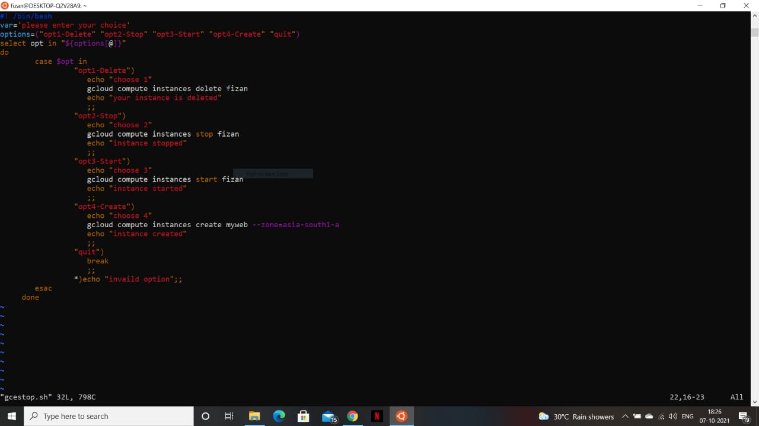

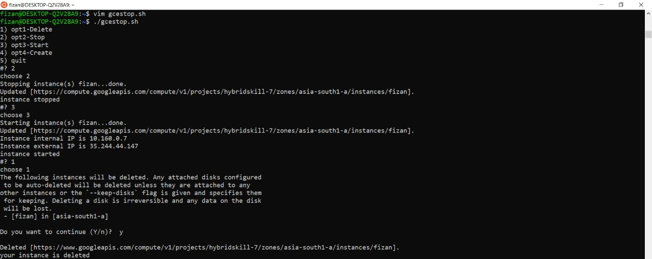

This script will create the following options in the instance like to delete, stop, start, create a particular instance.